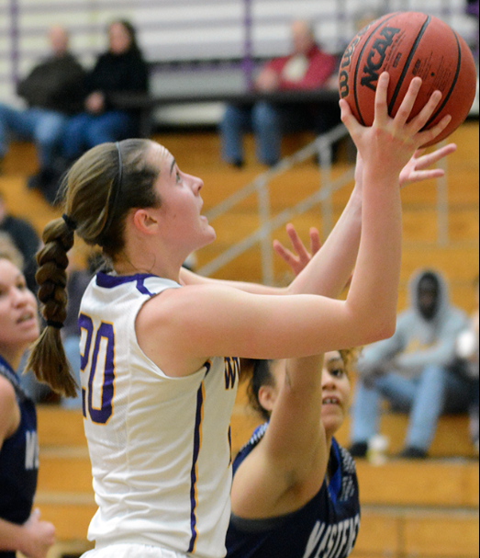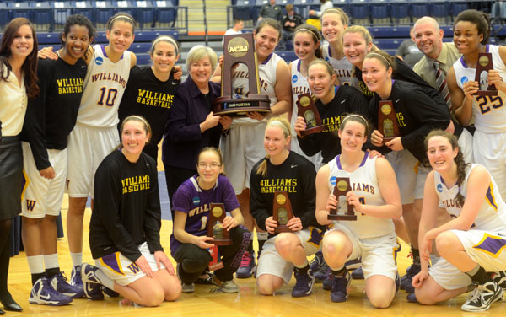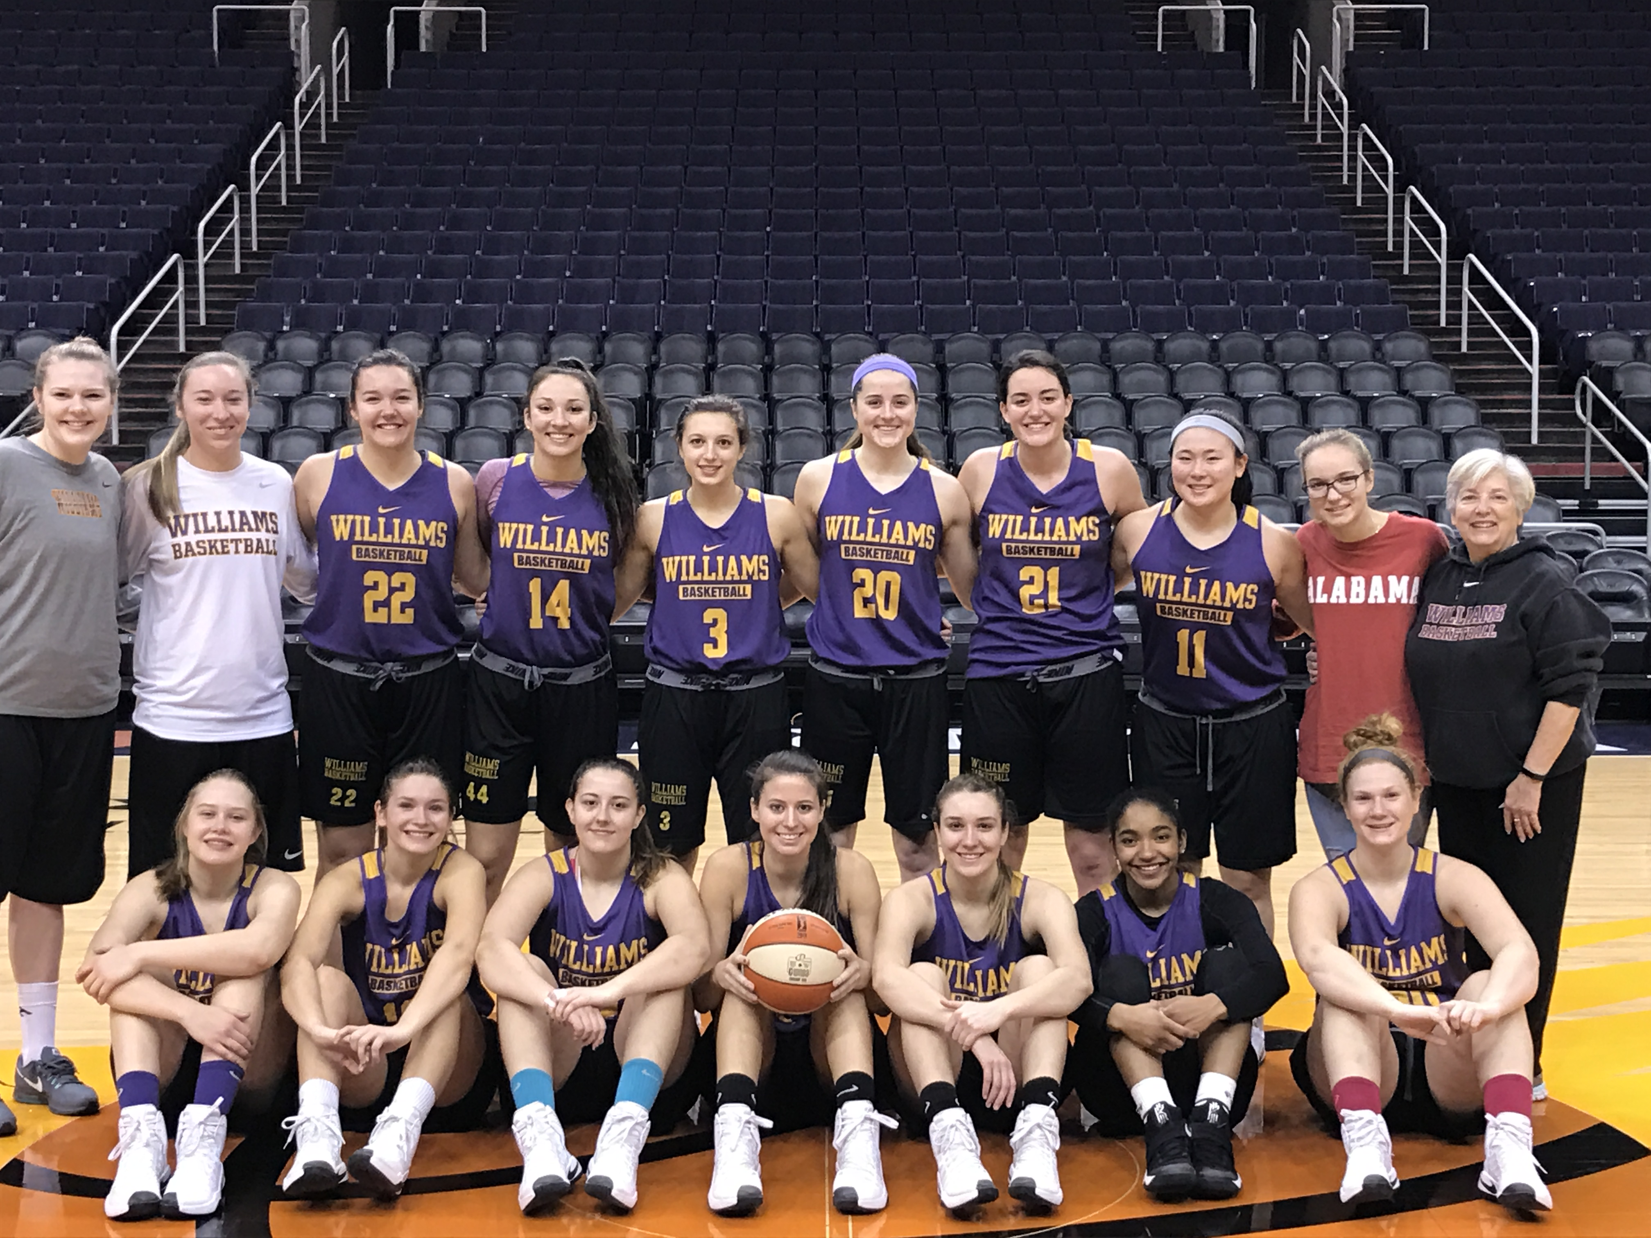

Senior Captain

#20 Kristin Fechtelkotter

## 2017 Girls Basketball Camp

## 475 Pine Cobble Road

## Williamstown, MA 01267

## Sign up Today!

Name:_______________________________________

Address: _____________________________________

____________________________________________

City, State, Zip: ________________________________

Cell Phone: ___________________________________

Age: ________________Grade (Fall 2016): _________

School: ______________________________________

Parent/Guardian(s) name(s): _____________________

____________________________________________

Parent E-mail: ________________________________

Reachable # Mother: ___________________________

Reachable # Father: ____________________________

Emergency #: _________________________________

Insurance Carrier: _____________________________

Policy Number: ________________________________

T-Shirt Size Circle: Youth sizes – S M L XL

Adult sizes – S M L XL

Yes, I am interested in transportation from: (circle one)

Adams/Cheshire Pittsfield/Dalton

Lee/Lenox

Circle applicable option:

$100 Deposit Payment in full $250

**Mail with check or money order payable to:**

Berkshire Girls Basketball Camp

475 Pine Cobble Road

Williamstown, MA 01267

The undersigned parent or guardian understands that applicant will be engaging in physical activity during the program which contains an inherent risk of physical injury and the undersigned assumes this risk and releases the Girls Basketball Camp and Williams College, their officers, directors, agents and employees from any and all liability for personal injury arising out of the applications participant in the camp program. I hereby grant permission for my daughter to attend the Girls Basketball Camp and be treated by a licensed physician or a member of the athletic training staff for any injury, illness or mishap. I further agree to pay through my insurance company or otherwise for any medical treatment that may be necessary. I certify that my child is in good health and is able to participate in all camp activities.

Williams College is not a sponsor or co-sponsor of the Girls Basketball Camp. The Girls Basketball Camp is in compliance with the Massachusetts General Program Requirements for Youth Camps (105 CMR 430.190.191).

Parent/Guardian Signature:

___________________________Date: ___________

This camp must comply with regulations of the Massachusetts Department of Public Heath and licensed by the local Board of Health.

## Camp Application

**At Williams College**

July 24th-28th

9am-3pm (M-TH)

9am-12pm (F)

2017

Girls Basketball Camp

**Final Four 2013**

**Basketball Highlights**

-Final Four Appearance: 2013

-Elite Eight Appearances: ’99, ‘13

-NCAA Appearances: ’97, ’99, ’06, ’07, ’10, ’11, ’13, ’14, **‘**15

-Little Three Titles: ’91, ’96, ’97, ’99, ’02, ’07 (Ties) ’94, ’95, ’98, ’03, ’04, ’05, ’06, ’13, ‘14

**2016-2017 Williams College**

**Women’s Basketball Team**

**HIGHLIGHTS:**

Optional swimming period each day

Each camper receives a t-shirt and basketball

Certificate of achievement

Guest Speakers

Transportation available within Berkshire County

Camp Store: Stocked with sports drinks, snacks, t-shirts, etc.…

Camper Awards

The 2016-17 season was the 27th of Pat Manning’s tenure at Williams. Manning is the all-time winningest coach in Williams history — men or women — she won her 400th game on February 16, 2013. Her career record stands at 478-210. She guided the Ephs to the Final Four in 2013 and to the Sweet 16 four times, including twice in the last seven years. She was recognized as a 2013 D3hoops.com Northeast Regional Coach of the Year. Coach Manning is serving her second term as a member of the WBCA Board of Directors.

Williams assistant coaches are Samantha Crough & Meredith Mesaris. Crough was a 1000 point scorer and Female Athlete of the year at Endicott College (’14). Mesaris was also a 1000 point scorer and a two time WBCA All American at the University of Scranton (’15).



For any additional questions please contact Pat Manning at pmanning@williams.edu

Or Samantha Crough at slc3@williams.edu

Quick Facts on Camp

**Price:** $250 per week. A $100 non-refundable deposit will reserve a camper’s place with the full balance due no later than one week prior to the first day of camp. Please make checks payable to “Berkshire Girls Basketball Camp”

**Family Discount:** You may subtract $25.00 from the total price for each additional camper after the first.

**Hours:** Chandler Gym will be opened and supervised by 8:45am each day. Campers should arrive no later then 8:55am and be picked up promptly at 3:00pm. Friday camp will go from 9am-12pm.

**What to bring:** Basketball shoes (or sneakers),socks, shorts, t-shirt, swimsuit, towel, lunch and a waterbottle.

**Transportation:** For an additional fee, transportation will be provided from outlying towns in Berkshire County. If interested please mark the appropriate space on the application. Information will be forwarded to you with your camper registration confirmation. **Transportation is limited, so please reply promptly!**

**Note:** Each camper must be covered by medical insurance. Policy names and numbers should be listed on the application form.

Camp Overview

The Williams College Girls Basketball Clinic provides an intensive weeklong opportunity for girls ages 6-16 to improve their basketball skills in a safe and supportive teaching atmosphere. The staff will provide instruction in the fundamentals of shooting, passing, ball handling, dribbling and individual and team defense. The basics of a fast break offense, the style played by the Williams Women’s Basketball Team, will be taught and developed in drills and live game situations. Highlighting the week will be league competition that will culminate in a round robin tournament on Friday. The teams will be formed according to age and ability. Contests, basketball videos and other fun activities will enhance the daily camp routine.

**NOTE**: Although parents and coaches are welcome to attend any of the camp sessions, the staff extends them a special invitation to Friday morning’s activities.

# Coaching Staff